# Docker: Enterprise Container Platform

Abdul Rehman Tariq

**Table of Contents**

1. How to install Dockers on your machine 2

2. Run Hello world 3

3. Define a container includes these files below 5

3.1 Dockerfile 5

3.2 Requirements.txt 8

3.3 App.py 8

4. How to build the app 10

5. How to run the app 10

6. How to share your image 11

7. How to tag and publish the image 11

8. How to pull and run the image from remote repository 12

**List of Figures**

Figure 1: Docker Information……………………………………………………………………………………………………3

Figure 2: Message Hello World…………………………………………………………………………………………………4

Figure 3: Listed Images…………………………………………………………………………………………………………....4

Figure 4: Listed Containers……………………………………………………………………………………………………….5

Figure 5: Existing Directories…………………………………………………………………………………………………….6

Figure 6: Directory path after Changed…………………………………………………………………………………….6

Figure 7: New file command…………………………………………………………………………………………………....7

Figure 8: New file editor…………………………………………………………………………………………………………..7

Figure 9: File with code…………………………………………………………………………………………………………….8

Figure 10: Save and exit command……………………………………………………………………………………………8

Figure 11: Encryption key…………………………………………………………………………………………………………9

Figure 12: New File………………………………………………………………………………………………………............9

Figure 13: New file……………………………………………………………………………………………………...............9

Figure 14: All files in existing directory…………………………………………………………………………………….10

Figure 15: Build the app………………………………………………………………………………………………………….11

Figure 16: Run the app……………………………………………………………………………………………………........11

Figure 17: Web page………………………………………………………………………………………………………………12

Figure 18: Login……………………………………………………………………………………………………………………..12

Figure 19: Tag name………………………………………………………………………………………………………………12

Figure 20: Docker hub repositories page……………………………………………………………………………….13

# Introduction

Docker is an open platform for developing, shipping, and running applications. Docker enables you to separate your applications from your infrastructure so you can deliver software quickly. With Docker, we can manage your infrastructure in the same ways you manage your applications.

Docker provides the ability to package and run an application in a loosely isolated environment called a container.  The isolation and security allow you to run many containers simultaneously on a given host. Containers are lightweight because they don’t need the extra load of a hypervisor, but run directly within the host machine’s kernel.

# Docker Engine

Docker Engine is a client-server application with these major components:

* A server which is a type of long-running program called a daemon process (the dockerd command).
* A REST API which specifies interfaces that programs can use to talk to the daemon and instruct it what to do.
* A command line interface (CLI) client (the docker command).

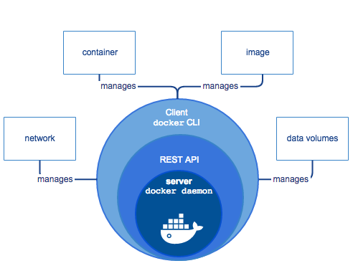

# How to install Dockers on your machine

**Step 1: Install Docker**

First install a latest stable version of Docker from the Docker community and also can download from this URL https://store.docker.com/editions/community/docker-ce-desktop-windows.

**Step 2: Install Git**

Next install GitBash for command line. I recommended GitBash instead of default windows cmd.

**Step 3: Test your Docker version**

You can check your version of Docker in command line by use this command.

docker --version (This command is used for Docker version checking)

The result produced by this command is below.

Docker version 17.12.0-ce, build c97c6d6

To view more details of Docker installation you can use below command.

docker info

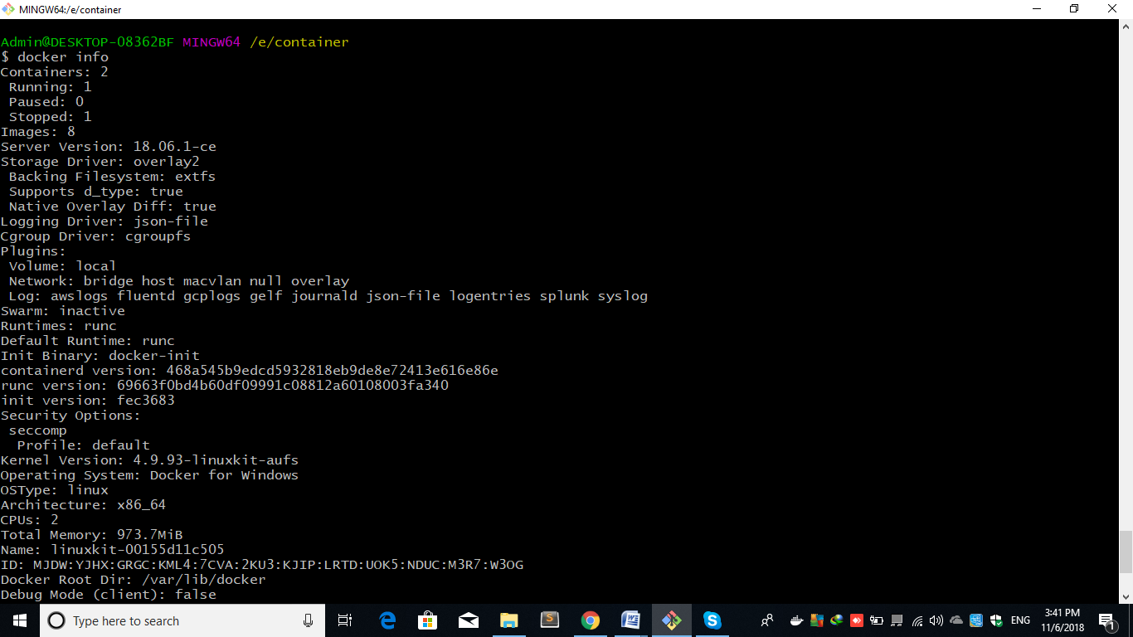 **Figure 1: Docker Information**

Figure 1 shows the result of command 🡪 docker info

# Run Hello world

To run your first hello world by image using this command below:

docker run hello-world (This Command is use for run the image)

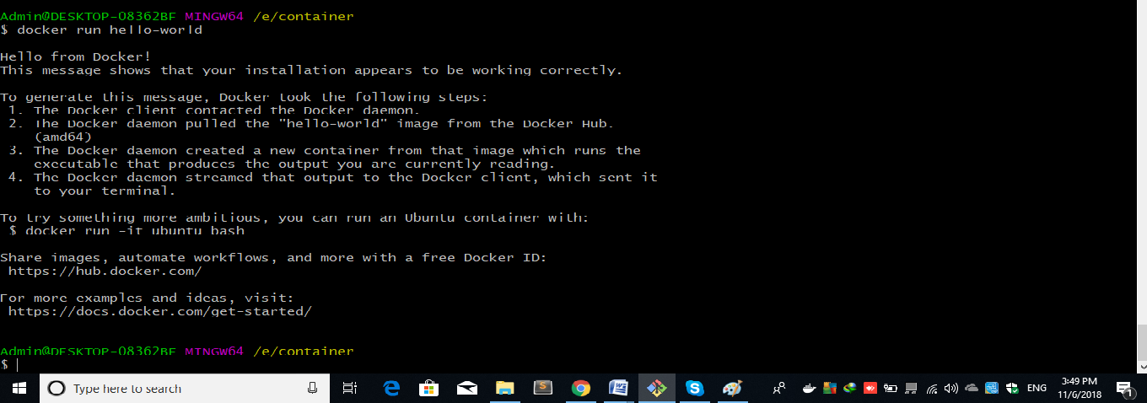

**Figure 2: Message Hello World**

Screen 2 shows the result of command 🡪 docker run hello-world

* 1. **Check your all listed images**

You can check your all list of images by using this command below:

docker image ls

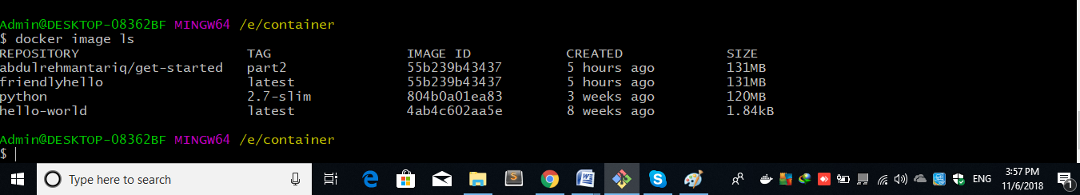**Figure 3: Listed Images**

Screen 3 shows the result of command 🡪 docker image ls

* 1. **Check your all listed container**

You can also check your all list of container by using this command below:

docker container ls –all

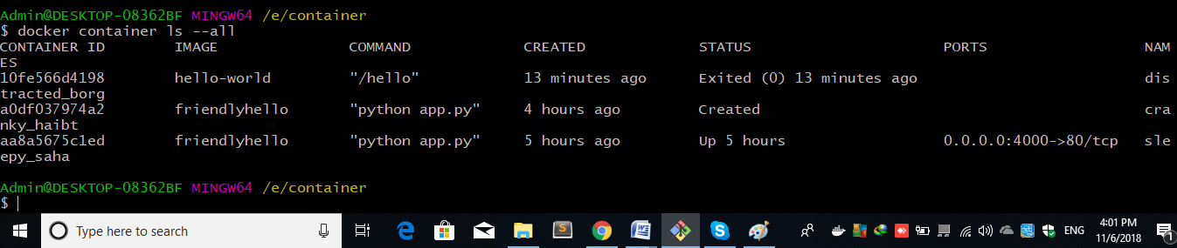

**Figure 4: Listed Containers**

Screen 4 shows the result of command 🡪 docker container ls –all

**Below the commands using for Docker initial steps:**

# Display Docker version and info

docker --version

docker info

# Run Docker image

docker run hello-world

# List Docker images

docker image ls

# List Docker containers (running, all)

docker container ls

docker container ls --all

# Define a container includes these files below

# Dockerfile

First create an empty folder in your disk by using this command below

mkdir Your Folder Name (This command is used for create new folder)

You can see and confirmed your existing folder by using this command below

ls (This command is used for seen the folders inside directory)

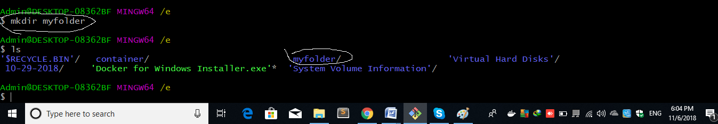

**Figure 5: Existing Directories**

Second move your current directory into your new make directory by using this command below:

cd your directory name (This command is used changed the directory)

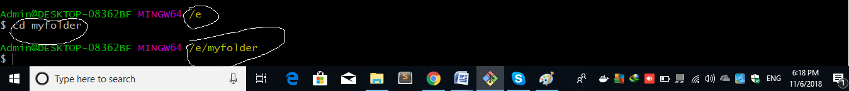

**Figure 6: Directory path after Changed**

Third make a new file in your new make directory as per instruction below and add all the references and libraries of python then save the file with the name dockerfile.

vim file name and press enter(This command is used for create and edit the file)

**Figure 7: New file command**

**After press enter it will show you this screen (figure 8)**

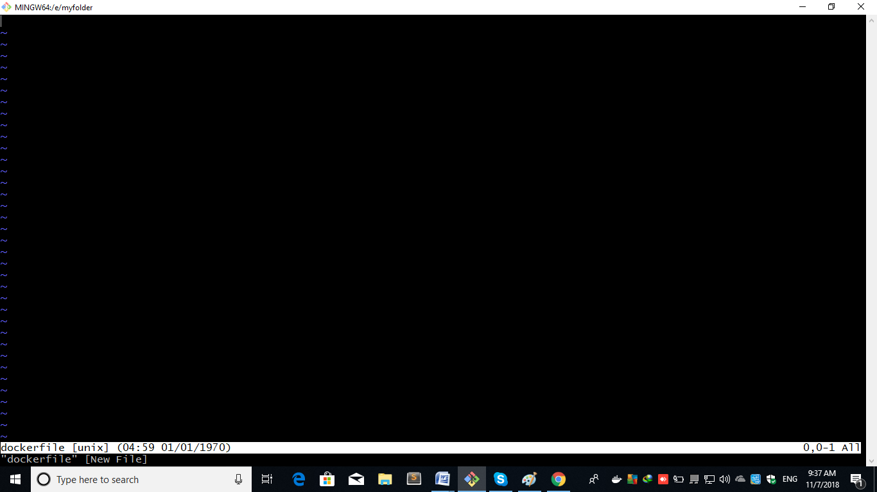

**Figure 8: New file editor**

In this screen copy paste the code below

# Use an official Python runtime as a parent image

FROM python:2.7-slim

# Set the working directory to /app

WORKDIR /app

# Copy the current directory contents into the container at /app

COPY. /app

# Install any needed packages specified in requirements.txt

RUN pip install --trusted-host pypi.python.org -r requirements.txt

# Make port 80 available to the world outside this container

EXPOSE 80

# Define environment variable

ENV NAME World

# Run app.py when the container launches

CMD ["python", "app.py"]

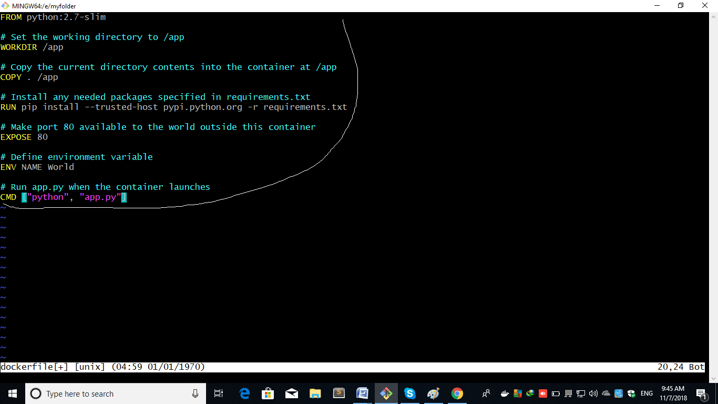

**Figure 9: File with code**

After the paste press esc and then enter **:x** you can see in Figure 10

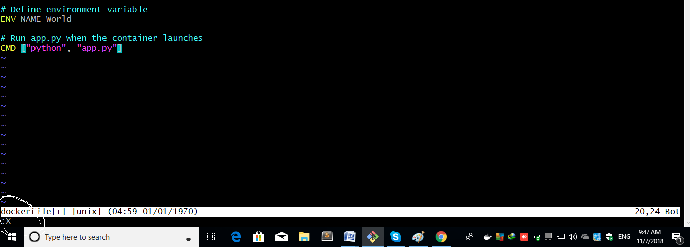

**Figure 10: Save and exit command**

After press if it will ask you for encryption key then enter any 5 digits or more numeric key like below

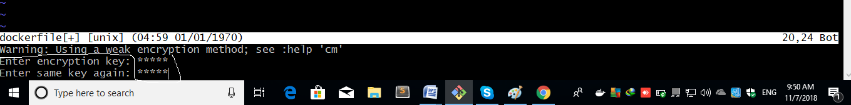

**Figure 11: Encryption key**

**If you are till on file edit screen then press again esc and enter :x again.**

# Requirements.txt

Now we create requirement file in the existing directory along docker file.

Again repeat the vim command now this time with the name requirements.txt like below



**Figure 12: New File**

After this press enter it will again move to you edit screen like Figure 8

Now copy and paste the code below

Flask

Redis

**After paste press esc and enter :x it will move back to you previous screen.**

# App.py

Now we create app.py file same like previous processes

Again enter vim command with name app.py and hit enter.



**Figure 13: New file**

After enter it will move to you edit screen like **figure 8**

Now copy paste the code below

from flask import Flask

from redis import Redis, RedisError

import os

import socket

# Connect to Redis

redis = Redis(host="redis", db=0, socket_connect_timeout=2, socket_timeout=2)

app = Flask(__name__)

@app.route("/")

def hello():

try:

visits = redis.incr("counter")

except RedisError:

visits = "<i>cannot connect to Redis, counter disabled</i>"

html = "<h3>Hello {name}!</h3>" \

"<b>Hostname:</b> {hostname}<br/>" \

"<b>Visits:</b> {visits}"

return html.format(name=os.getenv("NAME", "world"), hostname=socket.gethostname(), visits=visits)

if __name__ == "__main__":

app.run(host='0.0.0.0', port=80)

After paste press esc and enter :x like **Figure 10**

**After create successfully these files you can verify that these files are created or not in my directory by using this command below**

$ ls

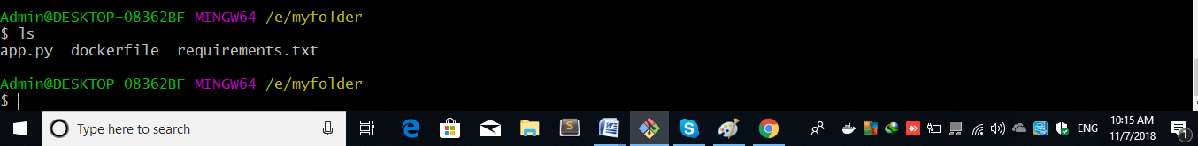

**Figure 14: All files in existing directory**

It will show you all the three files which we are created.

# How to build the app

Now you are able to build the app by using this command below it will creates a docker image and you can also verify this docker image

docker build -t friendlyhello .



**Figure 15: Build the app**

It will take some time be patient

You can verify your image by using this command

$ docker image ls

# How to run the app

Now we run the app by using this command below

docker run -p 4000:80 friendlyhello

After successfully run it will show you

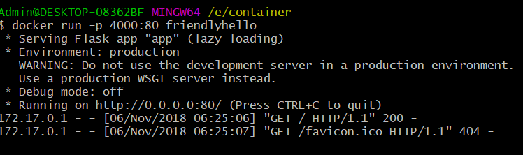

**Figure 16: Run the app**

Now you can see your app in browser by enter this URL <http://localhost:4000/>

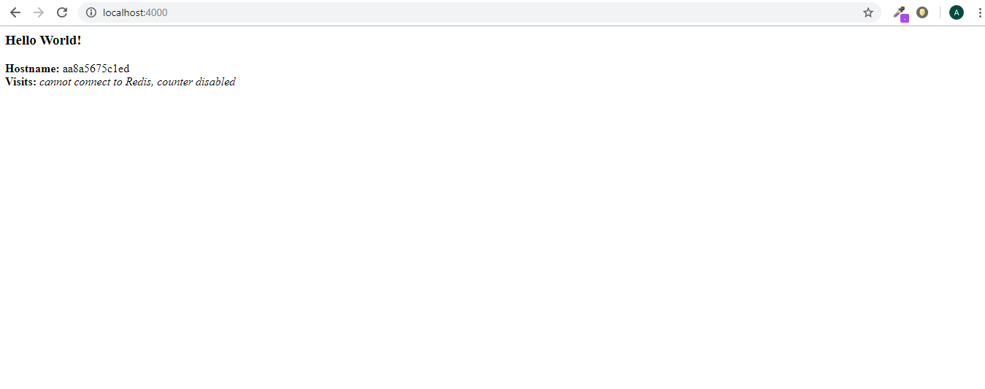

**Figure 17: Web page**

# How to share your image

You can share your image in docker hub by signing in docker account. If you have login credentials then by enter this command you will sign in.

$ docker login



**Figure 18: Login**

# How to tag and publish the image

Now if you want to publish your image docker recommended tag a image by this

docker tag image username/ repositoryname:tagname

docker hello.png

**Figure 19: Tag name**

Now you are able to push your image by using this command

docker push username/ repositoryname:tagname

# How to pull and run the image from remote repository

Now you can run your image with any machine by this command

docker run -p 4000:80 username/repositoryname:tagname

And you also verify your publish image in docker hub by signing in

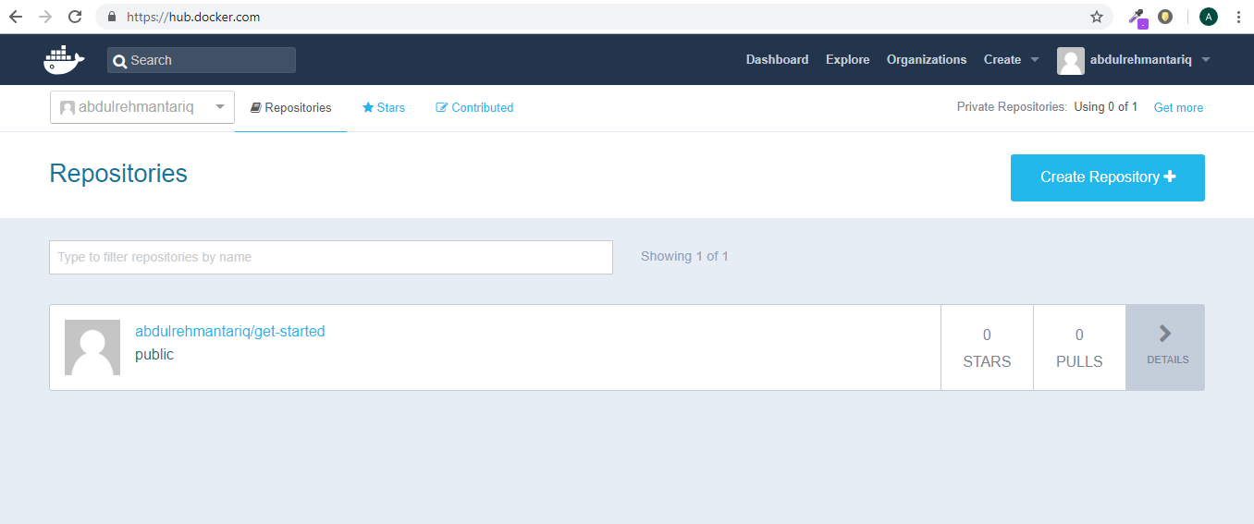

**Figure 20: Docker hub repositories page**